Part 1

* 1. VirtualBox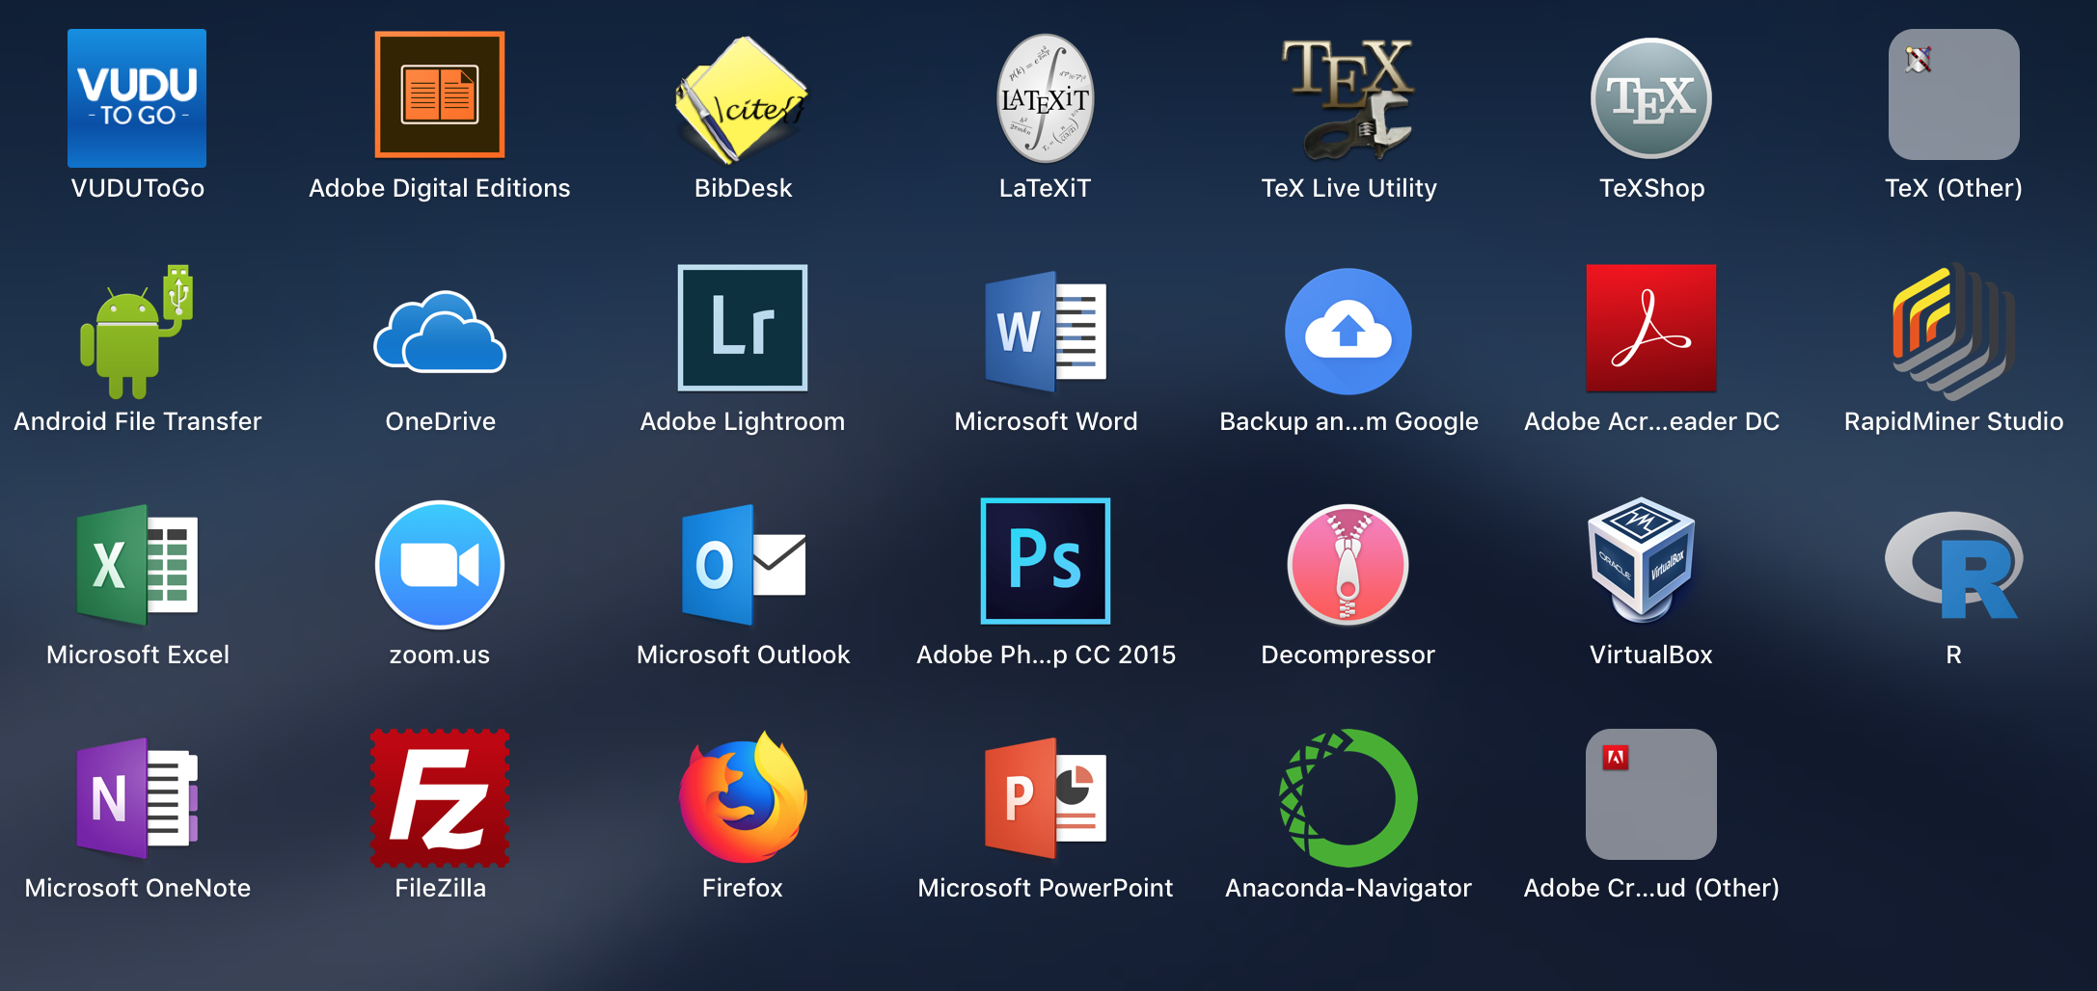
  2. Vagrant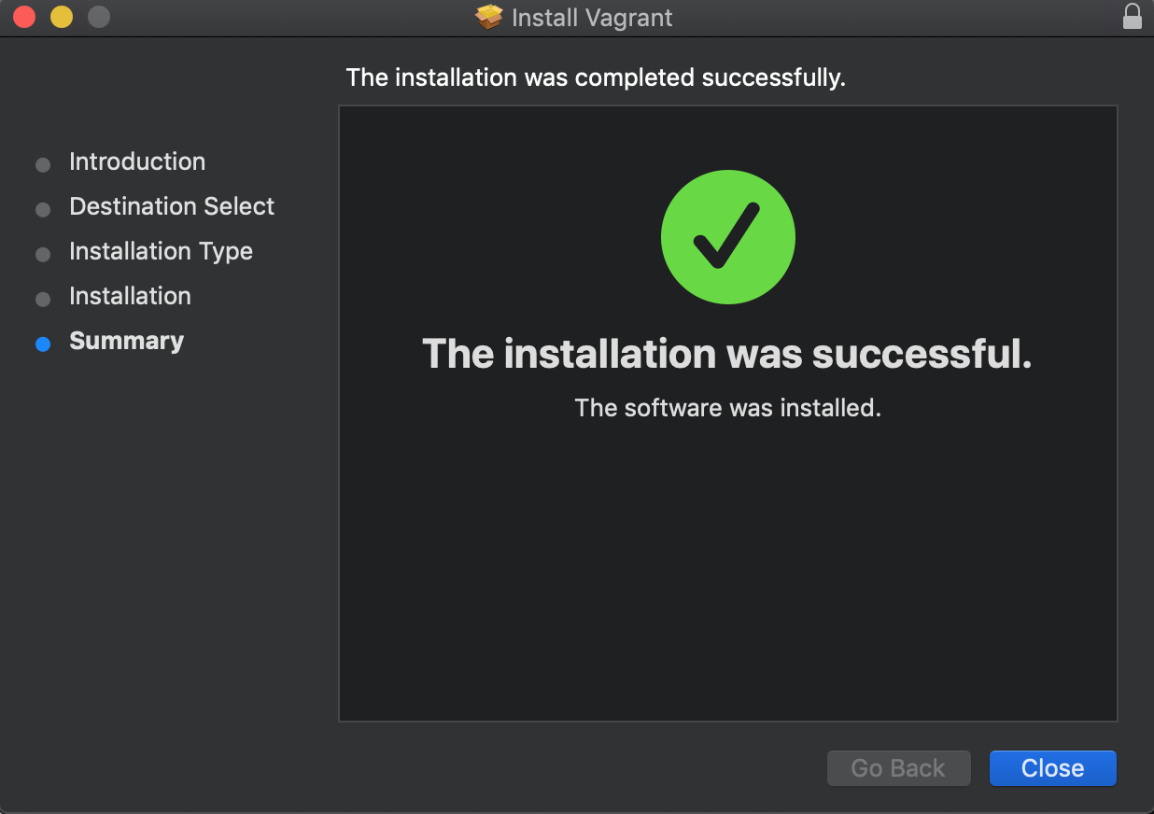
  3. Host Scripts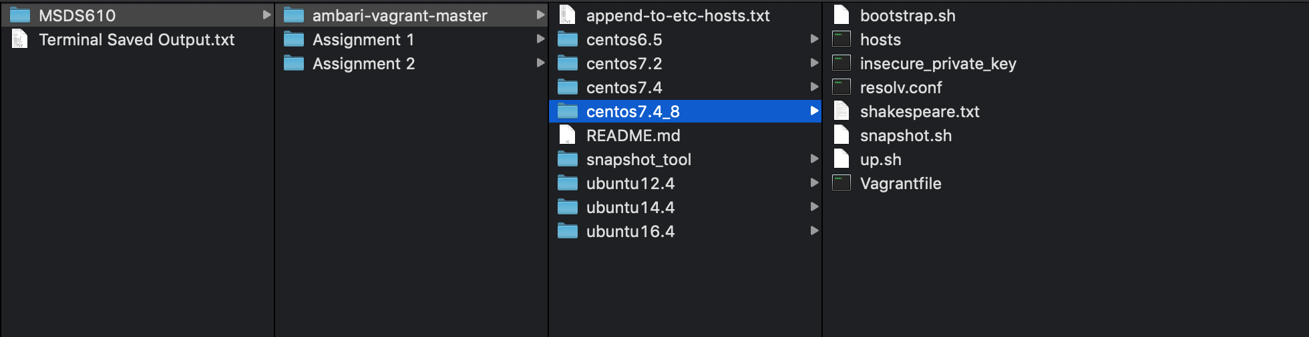
  4. Hosts File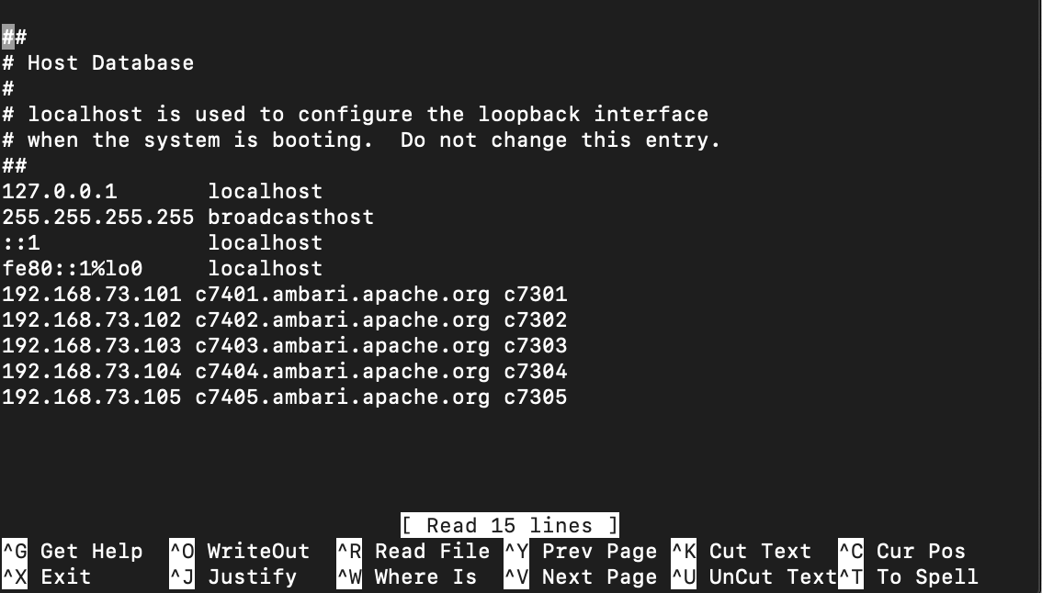
  5. Booting VMs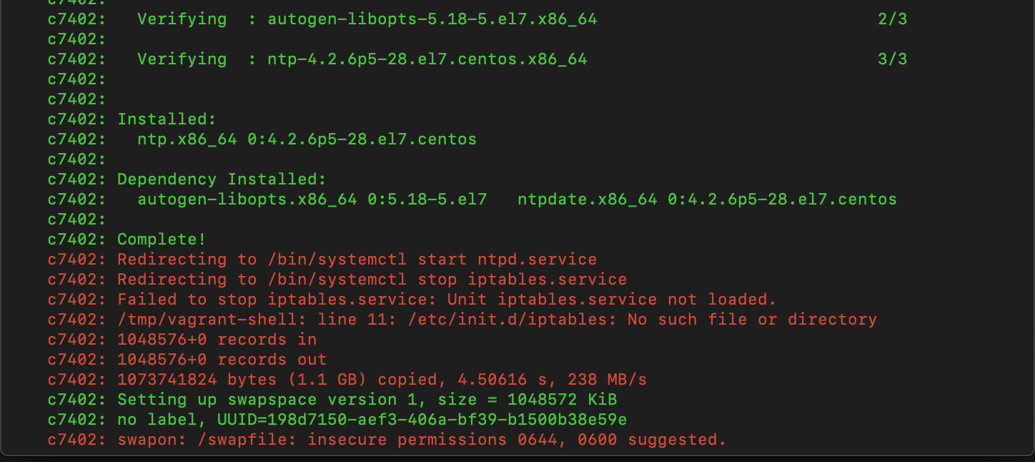

Part 2

* 1. Installing Ambari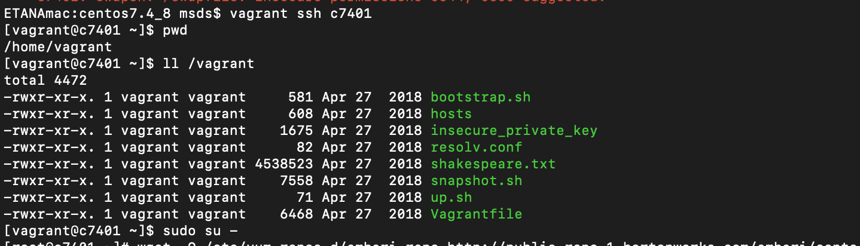

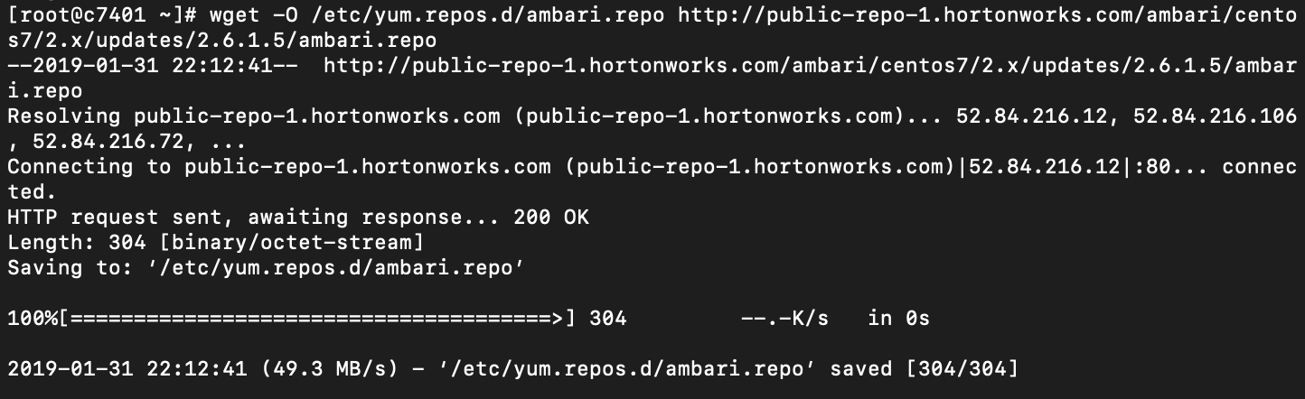

yum install -y ambari-server

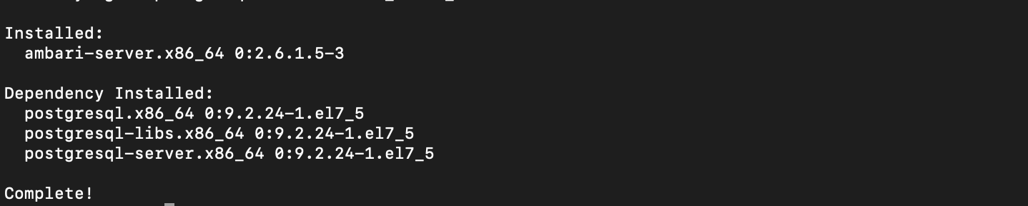  
  
ambari-server setup -s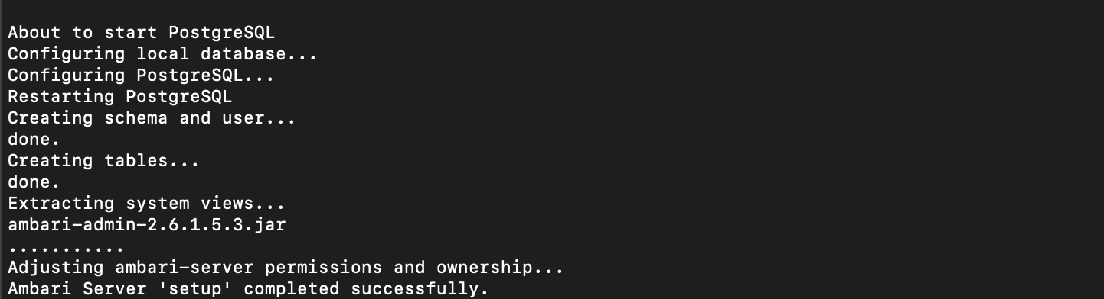

* 1. Installing MySQL Database and Connector  
     yum install -y mysql-connector-java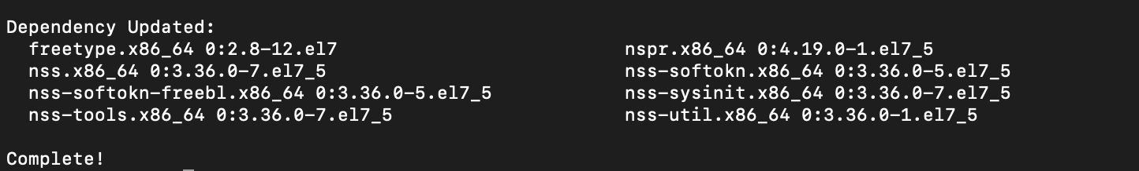  
     ambari-server setup --jdbc-db=mysql --jdbc-driver=/usr/share/java/mysql-connector-java.jar  
     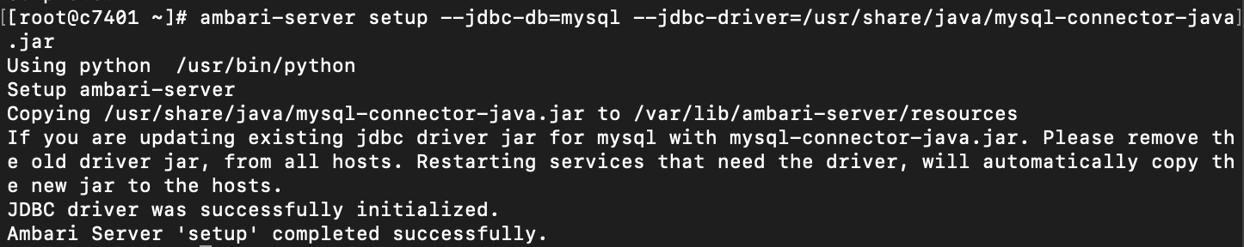  
     Putting MySQL on c7402.  
     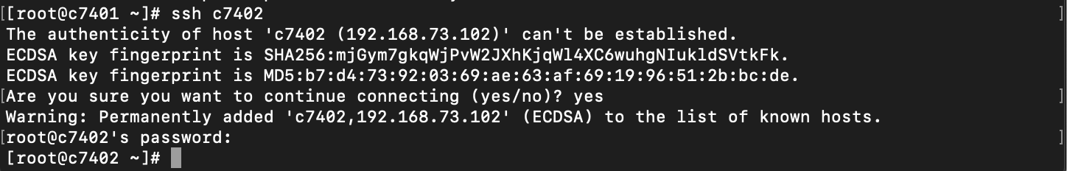  
     wget http://repo.mysql.com/mysql-community-release-el7-5.noarch.rpm  
     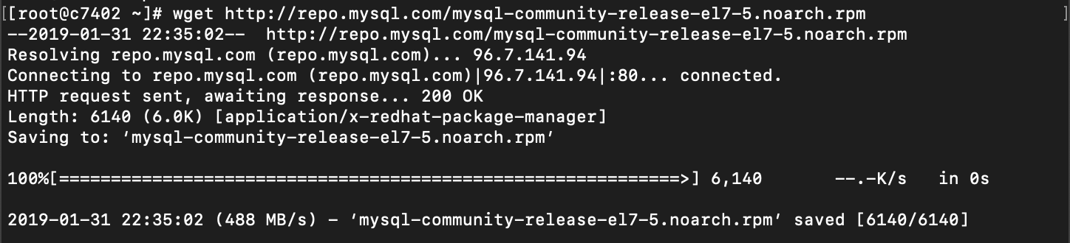  
     rpm -ivh mysql-community-release-el7-5.noarch.rpm  
     
  2. Start the Server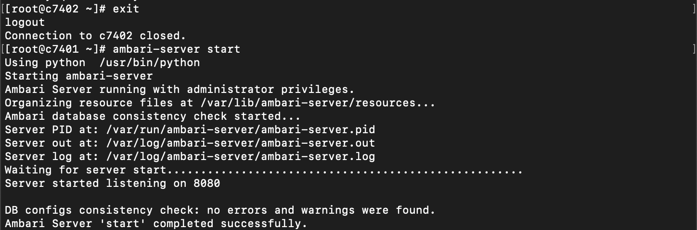

Part 3: Starting the Ambari User Interface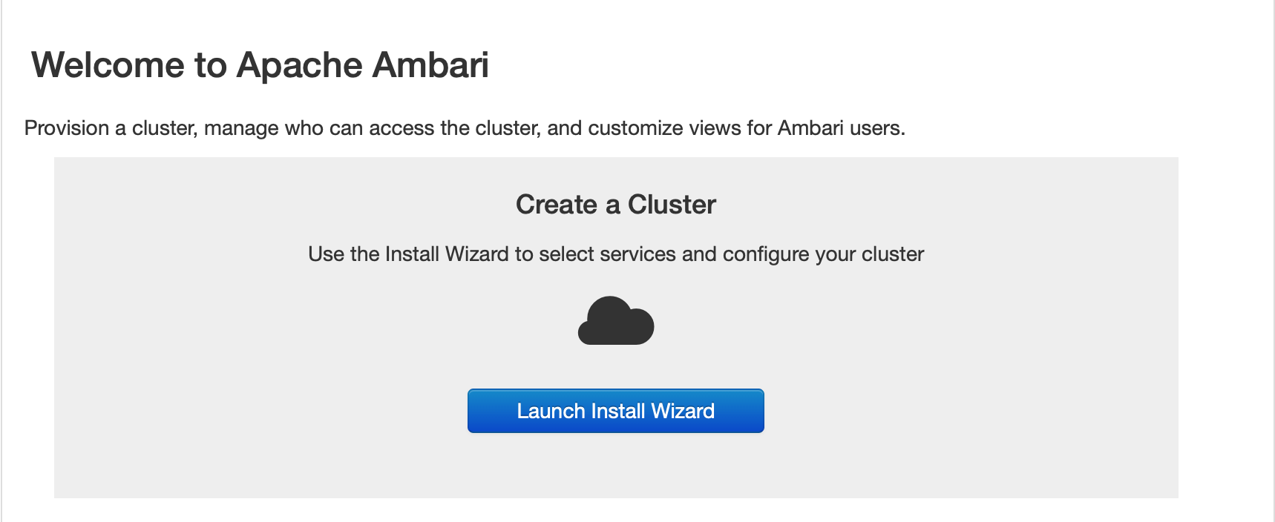

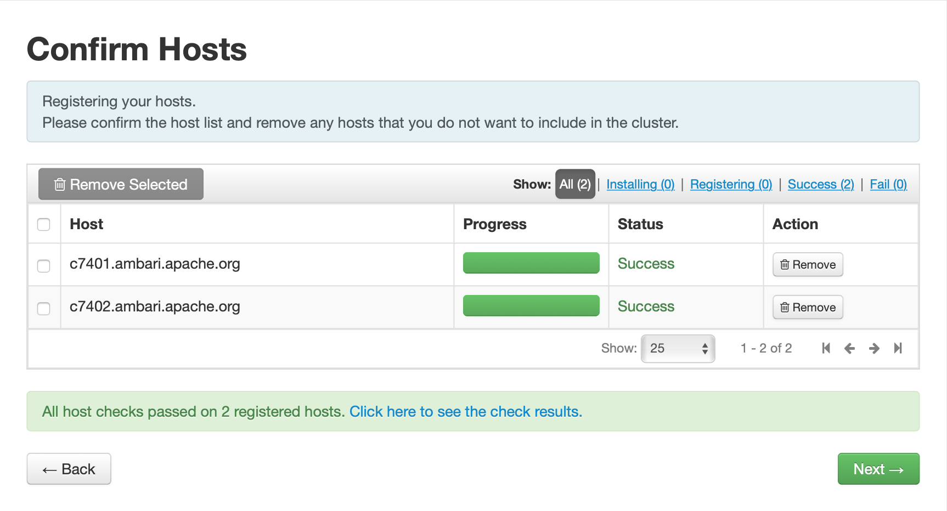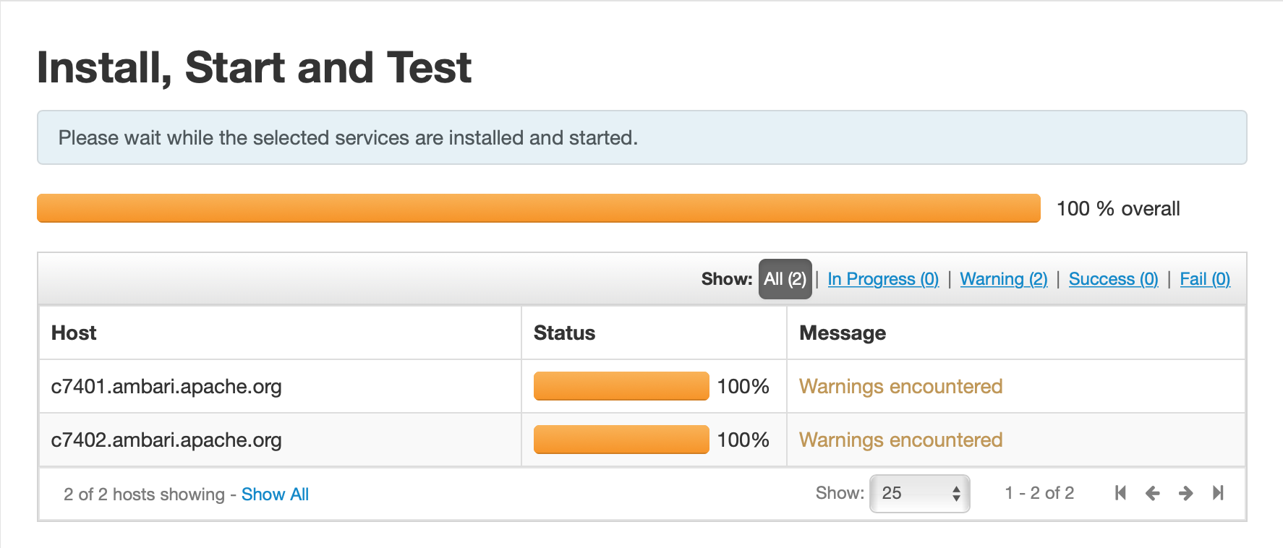

Silent download

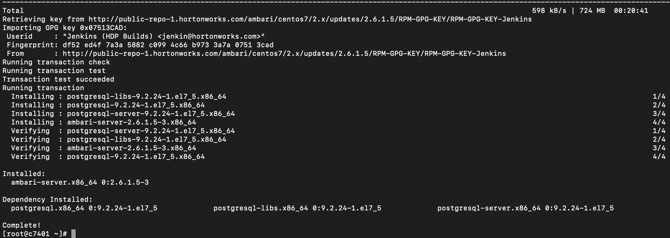

mysql



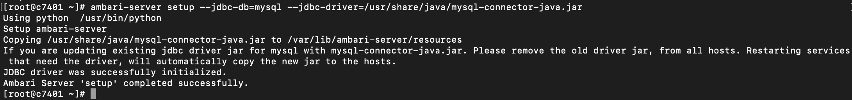

Sdsd

C740[1-2]

